Impact of Age On Academic Achievement

Yujing Fang, Chang Lian, Zhengdao Song

July 1, 2016

rm(list=ls(all=TRUE)) # Load libraries

library(dplyr)

##   
## Attaching package: 'dplyr'

## The following objects are masked from 'package:stats':  
##   
## filter, lag

## The following objects are masked from 'package:base':  
##   
## intersect, setdiff, setequal, union

# Load raw data

# Read all raw data  
data <- read.csv("result/reshaped_data.csv", stringsAsFactors = F)

# Exploratory Analysis

# numbers of variables and numbers of observations  
dim(data)

## [1] 186 18

# structure of variables  
str(data)

## 'data.frame': 186 obs. of 18 variables:  
## $ first_name : chr "james" "paul" "elaine" "anjon" ...  
## $ last_name : chr "thomson" "ahlquist" "alarid" "audhya" ...  
## $ gender : chr "male" "male" "female" "male" ...  
## $ current_age : int 58 63 54 42 60 65 56 44 52 64 ...  
## $ phd_age : int 30 28 29 28 30 28 27 31 30 28 ...  
## $ current_university : chr "university of wisconsin-madison" "university of wisconsin-madison" "university of wisconsin-madison" "university of wisconsin-madison" ...  
## $ current_university_rank : int 18 18 18 18 18 18 18 18 18 18 ...  
## $ current_university_tier : int 2 2 2 2 2 2 2 2 2 2 ...  
## $ bs_university : chr "university of illinois-urban champaign" "iowa state university" "university of california-berkeley" "brown university" ...  
## $ phd_university : chr "university of pennsylvania" "university of wisconsin-madison" "university of california-berkeley" "university of california-san diego" ...  
## $ year_get_bs : int 1981 1976 1985 1997 1979 1974 1983 1995 1987 1975 ...  
## $ year_get_phd : int 1988 1981 1991 2002 1986 1979 1987 2003 1994 1980 ...  
## $ num_articles : int 277 71 26 62 24 87 44 77 35 65 ...  
## $ num_peered_reviewed_articles : int 14 2 0 1 0 4 0 0 0 1 ...  
## $ percent_peered_reviewed_articles: num 0.0505 0.0282 0 0.0161 0 0.046 0 0 0 0.0154 ...  
## $ num_nature : int 9 1 0 0 0 2 0 0 0 0 ...  
## $ num_cell : int 3 0 0 1 0 1 0 0 0 0 ...  
## $ num_science : int 2 1 0 0 0 1 0 0 0 1 ...

# Descriptive statistics  
summary(data)

## first_name last_name gender current_age   
## Length:186 Length:186 Length:186 Min. :32.00   
## Class :character Class :character Class :character 1st Qu.:46.00   
## Mode :character Mode :character Mode :character Median :53.00   
## Mean :54.28   
## 3rd Qu.:63.00   
## Max. :88.00   
##   
## phd_age current_university current_university_rank  
## Min. :25.0 Length:186 Min. : 1.00   
## 1st Qu.:28.0 Class :character 1st Qu.: 4.00   
## Median :29.0 Mode :character Median :18.00   
## Mean :29.2 Mean :17.65   
## 3rd Qu.:30.0 3rd Qu.:19.00   
## Max. :37.0 Max. :55.00   
##   
## current_university_tier bs_university phd_university   
## Min. :1.000 Length:186 Length:186   
## 1st Qu.:1.000 Class :character Class :character   
## Median :2.000 Mode :character Mode :character   
## Mean :1.769   
## 3rd Qu.:2.000   
## Max. :3.000   
##   
## year_get_bs year_get_phd num_articles   
## Min. :1951 Min. :1957 Min. : 0.00   
## 1st Qu.:1976 1st Qu.:1982 1st Qu.: 24.00   
## Median :1986 Median :1992 Median : 50.50   
## Mean :1985 Mean :1991 Mean : 86.26   
## 3rd Qu.:1993 3rd Qu.:2000 3rd Qu.: 98.75   
## Max. :2007 Max. :2012 Max. :698.00   
##   
## num_peered_reviewed_articles percent_peered_reviewed_articles  
## Min. : 0.000 Min. :0.00000   
## 1st Qu.: 0.000 1st Qu.:0.00000   
## Median : 1.000 Median :0.02840   
## Mean : 7.301 Mean :0.06084   
## 3rd Qu.: 6.000 3rd Qu.:0.08947   
## Max. :152.000 Max. :0.36170   
## NA's :2   
## num_nature num_cell num_science   
## Min. : 0.000 Min. : 0.000 Min. : 0.000   
## 1st Qu.: 0.000 1st Qu.: 0.000 1st Qu.: 0.000   
## Median : 0.000 Median : 0.000 Median : 0.000   
## Mean : 2.753 Mean : 2.441 Mean : 2.108   
## 3rd Qu.: 2.000 3rd Qu.: 1.000 3rd Qu.: 2.000   
## Max. :74.000 Max. :48.000 Max. :42.000   
##

# Histogram  
hist(data$current_age)

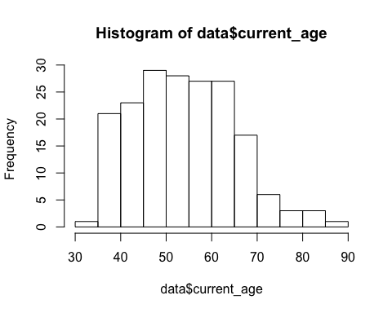

plot(density(data$current_age)) #kernel density estimate

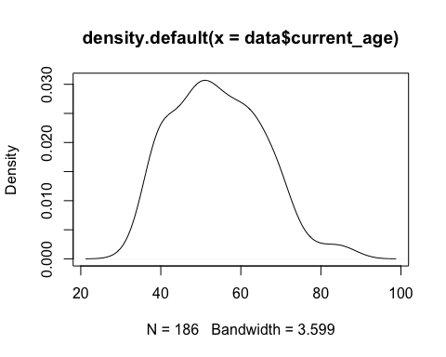

hist(data$phd_age)

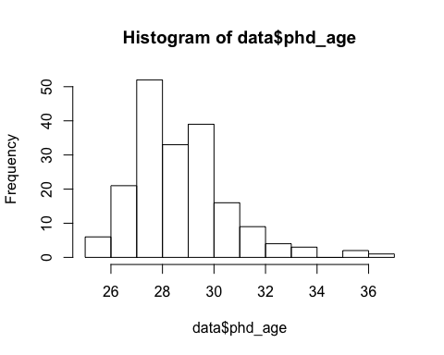

plot(density(data$phd_age))

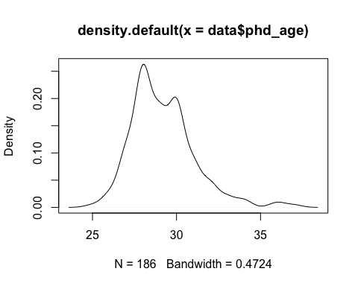

hist(data$num_articles)

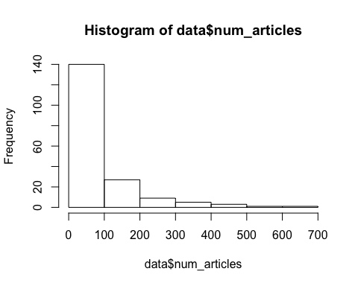

plot(density(data$num_articles))

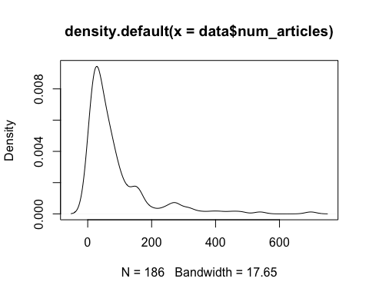

hist(data$num_peered_reviewed_articles)

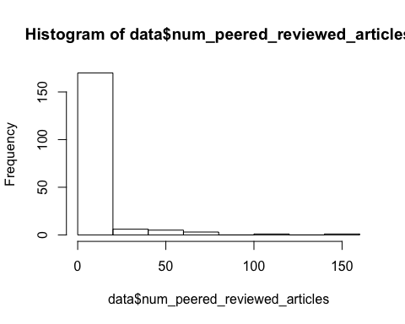

plot(density(data$num_peered_reviewed_articles))

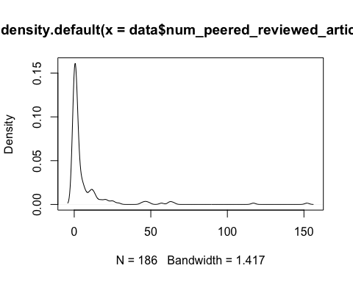

hist(data$percent_peered_reviewed_articles)

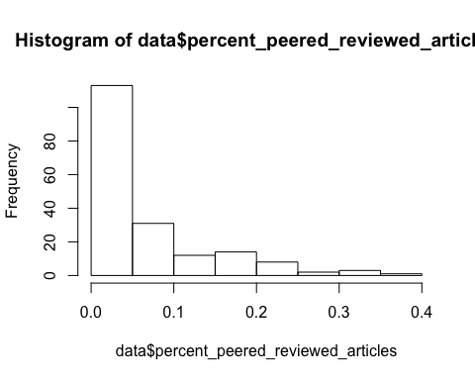

# Create scatterplots for numeric metircs  
data_numeric <- select(data, current_age, phd_age, current_university_rank, current_university_tier,num_articles, num_peered_reviewed_articles, percent_peered_reviewed_articles )  
  
pairs(data_numeric,panel=panel.smooth)

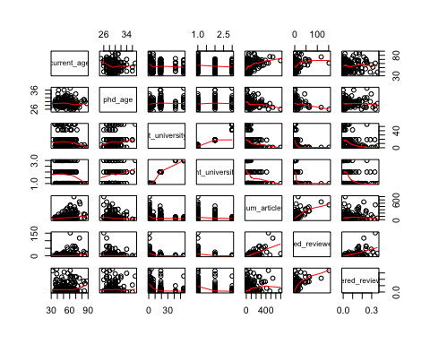  
 # Percentage of Peers Reviewed Articles ~ Ages Compared "centers" and "spreads" of Percentage of PR Articles across Ph.D Ages

boxplot(percent_peered_reviewed_articles ~ phd_age, data=data, main="Boxplots of Percentage of Peers Reviewed Articles Across Ph.D Ages", xlab="Ph.D Age", ylab="Percentage of PR Articles")

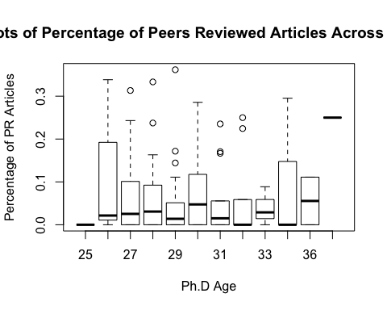  
 Compared "centers" and "spreads" of Percentage of PR Articles across Current Ages

boxplot(percent_peered_reviewed_articles ~ current_age, data=data, main="Boxplots of Percentage of Peers Reviewed Articles Across Current Ages", xlab="Current Age", ylab="Percentage of PR Articles")

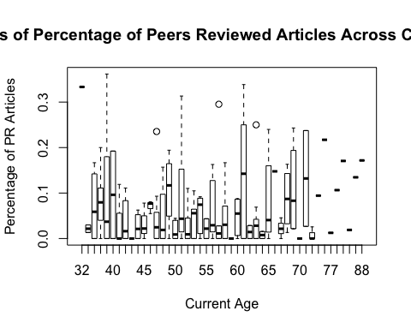  
 # Percentage of Peers Reviewed Articles ~ Universities Compared "centers" and "spreads" of Percentage of PR Articles across University Ranks

boxplot(percent_peered_reviewed_articles ~ current_university_rank, data=data, main="Boxplots of Percentage of Peers Reviewed Articles Across University Ranks", xlab="University Rank", ylab="Percentage of PR Articles")

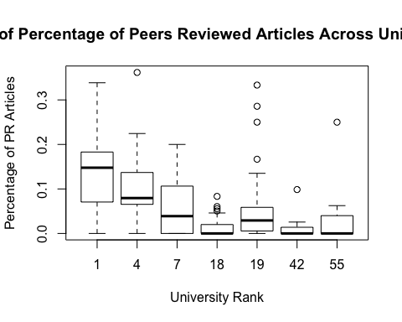  
 Compared "centers" and "spreads" of Percentage of PR Articles across University Tiers

boxplot(percent_peered_reviewed_articles ~ current_university_tier, data=data, main="Boxplots of Percentage of Peers Reviewed Articles Across University Tiers", xlab="University Tier", ylab="Percentage of PR Articles")

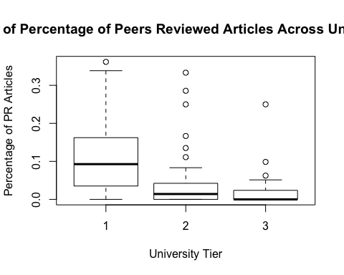  
 # Linear Regression for num_articles num_articles ~ current_age, phd_age, current_university_ranks

rg_articles <- lm(num_articles ~ current_age + phd_age + current_university_rank, data = data)  
summary(rg_articles)

##   
## Call:  
## lm(formula = num_articles ~ current_age + phd_age + current_university_rank,   
## data = data)  
##   
## Residuals:  
## Min 1Q Median 3Q Max   
## -193.84 -51.05 -16.75 21.98 515.04   
##   
## Coefficients:  
## Estimate Std. Error t value Pr(>|t|)   
## (Intercept) 223.6371 111.5189 2.005 0.046405 *   
## current_age 3.0714 0.6041 5.084 9.12e-07 ***  
## phd_age -9.4158 3.5648 -2.641 0.008976 **   
## current_university_rank -1.6501 0.4296 -3.841 0.000169 ***  
## ---  
## Signif. codes: 0 '***' 0.001 '**' 0.01 '*' 0.05 '.' 0.1 ' ' 1  
##   
## Residual standard error: 91.79 on 182 degrees of freedom  
## Multiple R-squared: 0.2509, Adjusted R-squared: 0.2386   
## F-statistic: 20.32 on 3 and 182 DF, p-value: 2.1e-11

# Linear Regression for log(num_articles)

log(num_articles) ~ current_age, phd_age, current_university_ranks

# Create a replica of 'data' data frame for adding log(num_article)  
data_log_num_articles <- data  
data_log_num_articles$log_num_articles <- log(data_log_num_articles$num_articles)  
  
# Drop -Inf  
data_log_num_articles <- subset(data_log_num_articles, log_num_articles!= "-Inf")  
  
# Run regression  
rg_articles_log <- lm(log_num_articles ~ current_age + phd_age + current_university_rank, data = data_log_num_articles)  
summary(rg_articles_log)

##   
## Call:  
## lm(formula = log_num_articles ~ current_age + phd_age + current_university_rank,   
## data = data_log_num_articles)  
##   
## Residuals:  
## Min 1Q Median 3Q Max   
## -3.9126 -0.5456 0.0126 0.5767 2.1265   
##   
## Coefficients:  
## Estimate Std. Error t value Pr(>|t|)   
## (Intercept) 6.792069 1.183636 5.738 3.98e-08 ***  
## current_age 0.033749 0.006472 5.215 5.02e-07 ***  
## phd_age -0.152472 0.037970 -4.016 8.69e-05 ***  
## current_university_rank -0.015894 0.004704 -3.379 0.000893 ***  
## ---  
## Signif. codes: 0 '***' 0.001 '**' 0.01 '*' 0.05 '.' 0.1 ' ' 1  
##   
## Residual standard error: 0.973 on 180 degrees of freedom  
## Multiple R-squared: 0.2792, Adjusted R-squared: 0.2671   
## F-statistic: 23.24 on 3 and 180 DF, p-value: 9.251e-13

# Linear Regression for num_peered_reviewed_articles

num_peered_reviewed_articles ~ current_age, phd_age, current_university_ranks

rg_peers_articles <- lm(num_peered_reviewed_articles ~ current_age + phd_age + current_university_rank, data = data)  
summary(rg_peers_articles)

##   
## Call:  
## lm(formula = num_peered_reviewed_articles ~ current_age + phd_age +   
## current_university_rank, data = data)  
##   
## Residuals:  
## Min 1Q Median 3Q Max   
## -22.275 -6.978 -3.163 2.372 132.938   
##   
## Coefficients:  
## Estimate Std. Error t value Pr(>|t|)   
## (Intercept) 31.1492 19.8344 1.570 0.11804   
## current_age 0.3505 0.1074 3.262 0.00132 **   
## phd_age -1.2750 0.6340 -2.011 0.04581 *   
## current_university_rank -0.3196 0.0764 -4.184 4.46e-05 ***  
## ---  
## Signif. codes: 0 '***' 0.001 '**' 0.01 '*' 0.05 '.' 0.1 ' ' 1  
##   
## Residual standard error: 16.33 on 182 degrees of freedom  
## Multiple R-squared: 0.1851, Adjusted R-squared: 0.1716   
## F-statistic: 13.78 on 3 and 182 DF, p-value: 3.889e-08

# Linear Regression for log(num_peered_reviewed_articles)

log(num_peered_reviewed_articles) ~ current_age, phd_age, current_university_ranks

# Create a replica of 'data' data frame for adding log(num_article)  
data_log_peers_articles <- data  
data_log_peers_articles$log_num_peered_reviewed_articles <- log(data_log_peers_articles$num_peered_reviewed_articles)  
  
# Drop -Inf  
data_log_peers_articles <- subset(data_log_peers_articles, log_num_peered_reviewed_articles!= "-Inf")  
  
# Run regression  
rg_peers_articles_log <- lm(log_num_peered_reviewed_articles ~ current_age + phd_age + current_university_rank, data = data_log_peers_articles)  
summary(rg_peers_articles_log)

##   
## Call:  
## lm(formula = log_num_peered_reviewed_articles ~ current_age +   
## phd_age + current_university_rank, data = data_log_peers_articles)  
##   
## Residuals:  
## Min 1Q Median 3Q Max   
## -2.42215 -0.83286 0.03809 0.71007 2.53055   
##   
## Coefficients:  
## Estimate Std. Error t value Pr(>|t|)   
## (Intercept) 3.130467 1.602115 1.954 0.053134 .   
## current_age 0.028019 0.008244 3.398 0.000932 ***  
## phd_age -0.088490 0.052382 -1.689 0.093866 .   
## current_university_rank -0.045526 0.006713 -6.782 5.41e-10 ***  
## ---  
## Signif. codes: 0 '***' 0.001 '**' 0.01 '*' 0.05 '.' 0.1 ' ' 1  
##   
## Residual standard error: 1.051 on 115 degrees of freedom  
## Multiple R-squared: 0.3792, Adjusted R-squared: 0.363   
## F-statistic: 23.42 on 3 and 115 DF, p-value: 6.671e-12

# Linear Regression for percent_peered_reviewed_articles

percent_peered_reviewed_articles ~ current_age, phd_age, current_university_ranks

rg_percent_peers <- lm(percent_peered_reviewed_articles ~ current_age + phd_age + current_university_rank, data = data)  
summary(rg_percent_peers)

##   
## Call:  
## lm(formula = percent_peered_reviewed_articles ~ current_age +   
## phd_age + current_university_rank, data = data)  
##   
## Residuals:  
## Min 1Q Median 3Q Max   
## -0.09817 -0.05548 -0.01404 0.02354 0.27772   
##   
## Coefficients:  
## Estimate Std. Error t value Pr(>|t|)   
## (Intercept) 1.298e-02 9.145e-02 0.142 0.887   
## current_age -8.261e-05 5.000e-04 -0.165 0.869   
## phd_age 2.970e-03 2.934e-03 1.012 0.313   
## current_university_rank -1.995e-03 3.635e-04 -5.490 1.35e-07 ***  
## ---  
## Signif. codes: 0 '***' 0.001 '**' 0.01 '*' 0.05 '.' 0.1 ' ' 1  
##   
## Residual standard error: 0.07518 on 180 degrees of freedom  
## (2 observations deleted due to missingness)  
## Multiple R-squared: 0.1463, Adjusted R-squared: 0.1321   
## F-statistic: 10.28 on 3 and 180 DF, p-value: 2.777e-06

# Linear Regression for log(percent_peered_reviewed_articles)

log(percent_peered_reviewed_articles) ~ current_age, phd_age, current_university_ranks

# Create a replica of 'data' data frame for adding log(num_article)  
data_log_percent_peers <- data  
data_log_percent_peers$log_percent_peered_reviewed_articles <- log(data_log_percent_peers$percent_peered_reviewed_articles)  
  
# Drop -Inf & NaN  
data_log_percent_peers <- subset(data_log_percent_peers, log_percent_peered_reviewed_articles!= "-Inf")  
data_log_percent_peers <- subset(data_log_percent_peers, log_percent_peered_reviewed_articles!= "NaN")  
  
# Run regression  
rg_percent_peers_log <- lm(log_percent_peered_reviewed_articles ~ current_age + phd_age + current_university_rank, data = data_log_percent_peers)  
summary(rg_percent_peers_log)

##   
## Call:  
## lm(formula = log_percent_peered_reviewed_articles ~ current_age +   
## phd_age + current_university_rank, data = data_log_percent_peers)  
##   
## Residuals:  
## Min 1Q Median 3Q Max   
## -2.38652 -0.66105 0.07245 0.64665 1.81650   
##   
## Coefficients:  
## Estimate Std. Error t value Pr(>|t|)   
## (Intercept) -4.792155 1.308400 -3.663 0.000379 ***  
## current_age -0.008371 0.006733 -1.243 0.216281   
## phd_age 0.099016 0.042779 2.315 0.022410 *   
## current_university_rank -0.028429 0.005482 -5.185 9.34e-07 ***  
## ---  
## Signif. codes: 0 '***' 0.001 '**' 0.01 '*' 0.05 '.' 0.1 ' ' 1  
##   
## Residual standard error: 0.8581 on 115 degrees of freedom  
## Multiple R-squared: 0.2098, Adjusted R-squared: 0.1892   
## F-statistic: 10.18 on 3 and 115 DF, p-value: 5.365e-06